GitaGuide: An Emotion-Aware, Explainable and Safety-Gated Guidance System
Grounded in the Bhagavad Gita and the Arthashastra
Interim Report
Submitted in partial fulfillment of the requirement for the award of
Degree of Bachelor of Technology in
Computer Engineering
Submitted to

SVKM's NMIMS,
Mukesh Patel School of Technology Management & Engineering,
Shirpur Campus (M.H.)
Submitted By:
Harikrishna Panchal Enrollment No. – [Enrollment No.]
Under The Supervision of:
Dr. Suresh Kurumbanshi
Project Guide, Department of Computer Engineering
DEPARTMENT OF COMPUTER ENGINEERING
Mukesh Patel School of Technology Management & Engineering
ACADEMIC SESSION: 2025-26

ABSTRACT
Scripture‑based chatbots are drawing users. Yet many failures have already been shown. Some Gita chatbots have even said that killing can be acceptable when it is seen as a duty. Studies also point out worries about claims, bias and emotional dependence.

This project introduces GitaGuide, a guidance system made from the Bhagavad Gita with 701 verses and the Arthashastra with 3,135 sutras. GitaGuide scores each message for emotion and intensity decides an intent. Then runs a layered crisis check before it pulls or creates content. The system pulls verses from a knowledge graph that holds 3,836 verses. Every citation that appears in a reply must come from a verse that GitaGuide has retrieved for that answer.

At this stage the crisis check stopped all 36 crisis prompts and let through all 25 benign prompts. A router stopped retrieval on all 20 non‑guidance turns cutting retrieval from 20 cases to none. The full system now uses 429 MiB of its 512 MiB memory limit.

A second round of tests included component ablations, an emotion test on held‑out data, a live intent test and a graded red‑team test. The emotion test earned a macro‑F1 score of 0.451. Intent accuracy was 65 percent and scripture questions were rarely answered correctly. In the red‑team test two of 25 harm‑oriented prompts received answers that supported violence. Both problems have been fixed in the code. Those fixes are not yet in production. Retrieval is still weak with a hit‑rate‑at‑5 of 0.175. The faithfulness score of 2.77, out of 5 is only preliminary.
TABLE OF CONTENTS
 | Abstract | 2
 | List of Figures | 4
 | List of Tables | 4
1 | Introduction | 5
1.1 | Background of the Project Topic | 5
1.2 | Motivation and Scope of the Report | 5
1.3 | Problem Statement | 5
1.4 | Salient Contribution | 6
1.5 | Organization of the Report | 6
2 | Literature Survey | 7
2.1 | Introduction to Overall Topic | 7
2.2 | Exhaustive Literature Survey | 7
3 | Methodology and Implementation | 9
3.1 | Block Diagram | 9
3.2 | Hardware Description | 10
3.3 | Software Description, Flowchart / Algorithm | 10
4 | Result and Analysis | 13
4.1 | Progress Made | 13
4.2 | Measured Results | 13
5 | Advantage, Limitations and Applications | 21
5.1 | Advantages | 21
5.2 | Limitations | 21
5.3 | Applications | 21
6 | Conclusion and Future Scope | 22
 | References | 23
 | Appendix A: List of Paper Presented and Published | 24

LIST OF FIGURES
Fig. 1 | The GitaGuide Pipeline (Architecture / Block Diagram) | 9
Fig. 2 | Component Diagram of the Deployed System | 9
Fig. 3 | Median Per-Stage Latency of a Normal Turn (Live Stack) | 14
Fig. 4 | Resident Memory Before and After INT8 Optimisation | 15
Fig. 5 | Closed-Beta Notice and Consent Screen | 18
Fig. 6 | Guidance Answer with Cited Verses and Trace | 19
Fig. 7 | Crisis Gate Response | 19

LIST OF TABLES
Table 1 | Capability Comparison with the Closest Precedents | 8
Table 2 | Hardware Description | 10
Table 3 | Software Description | 10
Table 4 | Layers of the Safety Gate | 11
Table 5 | Safety Gate Results | 13
Table 6 | Second Red-Team Assessment | 14
Table 7 | Effect of Conversational Routing | 15
Table 8 | Intent Classification, Per-Class Metrics | 16
Table 9 | Intent Confusion Matrix | 16
Table 10 | Emotion Model on GoEmotions Test Split | 16
Table 11 | Retrieval on the 40-Query Gold Set | 17
Table 12 | Component Ablations | 17
Table 13 | First Human Evaluation of 30 Answers | 18

Chapter 1
Introduction

1.1 Background of the Project Topic
Spiritual advice usually happens through a conversation. A student talks with a teacher shares a struggle. Gets guidance that fits their situation. This kind of exchange is hard to do for many people at once. Large language models can reach a lot people. Now chatbots based on the Bhagavad Gita are answering questions about grief, stress from exams, family. Deciding to leave a job.

Making a chatbot is not just about finding the right lines from the text. It needs to understand what the user is saying. It must sense the emotions behind the words figure out what kind of support is needed find the verses from the Gita and give an answer that is both helpful and well-sourced. Search tools and knowledge graphs can help find and cite the passages but they don’t make the system safe.

The dangers are already visible. In 2023 a CBC investigation found that least three, out of five Gita chatbots told users that killing could be acceptable if it was part of their dharma. These answers used verses from the text but still led to harmful messages. That’s why we built safety checks into every part of the process. We didn’t just add them at the end. We made safety a core part of how the system works, from the start.
1.2 Motivation and Scope of the Report
The project started because of three problems. Scripture chatbots often do not have protection and can be made to support violence [5]. Their responses to emotions are usually simple. Do not tell the difference between small worries and real sadness. They also do not check if the references they use are correct incorrect verse numbers can look right.
This report explains the project at this point in time including how it was built how it was used and what was found. Some results were not as good as expected especially when it came to finding information. The results are shown as they were recorded. Chapter 4 explains which tests were done alone and which were not.

1.3 Problem Statement
Current systems that use scripture for guidance have four issues. This project tries to solve all four at the same time.
• Most of them are not safe. Every message goes directly to finding and creating answers even when it is sensitive.
• They do not take into account how strong the emotion is, so sadness and a small interest get the kind of answer.
• No one checks the references. An answer can mention a verse that was never found or does not even exist.

1.4 Salient Contribution
The work includes five contributions, each implemented and tested.
• A crisis gate checks messages before they reach memory, routing, retrieval or generation. Blocked messages cannot be used to generate an answer or receive a citation.
• A knowledge graph contains 3,836 verses from the Bhagavad Gita and the Arthashastra. It connects verses through emotions, themes and concepts. After hub suppression the graph can run on a free graph database.
• The citation checker compares each verse ID in an answer, with the retrieved verses. If a check fails the system retries once builds a fallback answer directly from the retrieved verses.
• The live system was measured for safety, routing, retrieval, intent, emotion and answer quality. The results include measures that performed poorly.
• A second red-team review found two safety failures. Both were fixed in the code. The fix has not yet been deployed.
1.5 Organization of the Report
Chapter 2 looks at studies and points out what is missing. Chapter 3 goes into how the study was set up. Chapter 4 shows the system that was built and shares what the tests found. Chapter 5 talks, about the advantages, shortcomings and possible applications. Chapter 6 wraps up the findings. Shows what still needs to be done.

Chapter 2
Literature Survey

2.1 Introduction to Overall Topic
We reviewed 34 sources published between 2023 and 2026. They examine AI tools based on scripture, language models that address emotion and safety, knowledge-graph retrieval, and critical research on faith-based chatbots.
After the initial review, we searched again to test whether a research gap really existed. Search terms included "religious chatbot bias," "chatbot dependency," and "GraphRAG limitations." We found five sources missed earlier, and each led us to revise statements in the text below.
2.2 Exhaustive Literature Survey
The three studies are based upon the Gita. Dhokane et al. [1] use a fine-tuned BERT and GPT-2 in conjunction with a FAISS index of SentenceBERT embeddings. Their accuracy is 91.4%, which is 30% above the keyword accuracy of approximately 60%. The paper doesn't explain how that number was arrived at, and there is no emotional, intent or layer of safety in the system. In order to build a dialogue model for emotional support, Kapuriya et al. [2] created a model called Spiritual-LLM based on the Gita. It lacks a knowledge graph, memory across turns and explanations, and is without a safety filter. Quran Chat is not a research paper. It fetches verses and interpretations from the Quran, tafsir and sunnah, cites them and claims the figure of 86% without being adversarial. It does not have detection of emotions, and it only has a general safety disclaimer. The best indication of risk is from Shivji's report for CBC News [5]. For three out of five deployed Gita chatbots, it was duty to accept violence, and they quoted actual verses.
Safety is discussed by Aharon et al. [3] who present SAGE, a counselling framework based on a knowledge graph and a strategy that is aware of the crisis. Experts evaluated it. It is not scripture-based nor does it have an intensity of emotions. Ni and Yang [8] consider another problem. When an emotional conversation is cut short by a safety system, it may feel rejected by a user who's become attached to the system. They persist in their call to decrease the conversation slowly.
In the realm of retrieval, GraphRAG shows that questions about a whole corpus are harder to answer without graph structure, compared to using plain vector search. It can be ~2x-3x the latency and requires a significant indexing step. According to surveys, explainability is the least developed area of graph and LLM systems. So for each verse that is retrieved, GitaGuide saves the path of the graph.
From the critical literature we were provided with some requirements. Biana [6] analyzed religious chatbots deployed and observed that they gave incorrect responses to questions, or had gender bias, unless they were corrected. In Scientific American, Wright summarizes Noreen Herzfeld's comments about the potential for hallucination with any language model. In a study of Reddit communities, Zhu, Coifman and Jin [7] identified emotional dependency as one of the most-often reported risks faced by users. The emotion label and embedding design is based on GoEmotions [9] and Sentence-BERT [10], respectively.From this we took five requirements. Safety must come before retrieval and generation and must be testable. Every citation must be checkable. Each answer must have an explanation stored. Strength of emotion is as important as its nature. And the system needs to be low cost for a small research beta. We found no reviewed system that has emotion intensity, retrieval over two scriptures, graph explanations, a safety gate and memory together. Table 1 makes a comparison of GitaGuide with the closest of the guides.
Table 1: Capability comparison with the closest precedents
System | Text | Emotion | Knowledge graph | Safety | Two texts
Dhokane et al. [1] | Gita | No | No | No | No
Spiritual-LLM [2] | Gita-inspired | Yes | No | No | No
SAGE [3] | Counselling | No intensity | Yes | Yes | n/a
Quran Chat | Quran, tafsir, Sunnah | No | Not reported | Disclaimer only | n/a
GitaGuide (this project) | Gita + Arthashastra | Yes, with intensity | Yes | Four input layers, five output patterns | Yes

Chapter 3
Methodology and Implementation

3.1 Block Diagram
One fixed pipeline is GitaGuide, which is safe at the fore. Emotion detection, intention recognition, input safety gate, memory, router, retrieval, generation, output gate and storage. The gate precedes memory, routing, retrieval and generation, therefore there is no weakening going on after it. When the message is not accepted, it is sent a fixed reply from the helpline and does not go through those steps. The orchestrator makes sure that the order is maintained. It is used in unit tests, production smoke test and the API layer check it and the API layer removes it from any blocked turn.
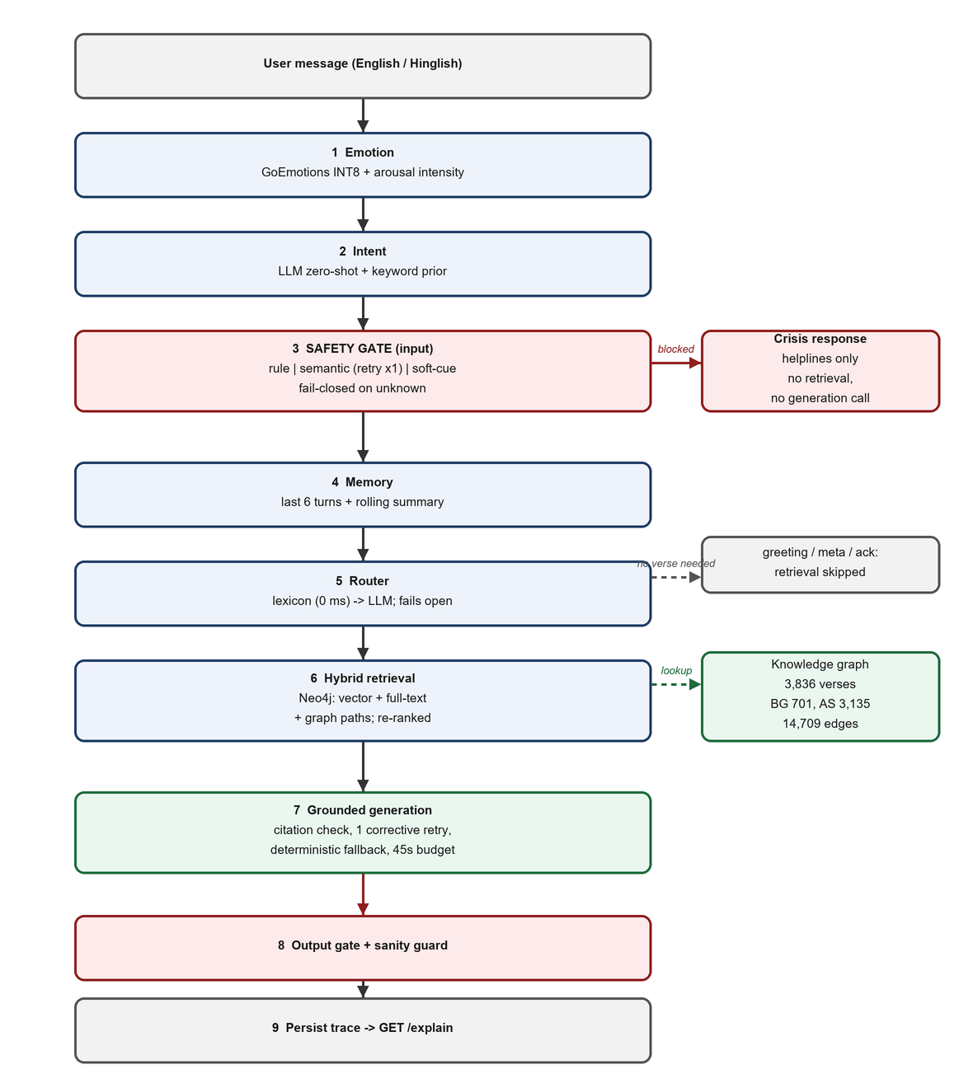
Figure 1: The GitaGuide pipeline (block diagram). Shaded stages are safety gates. A blocked turn leaves after stage 3 with the helpline response only; routes that need no verse skip stage 6.

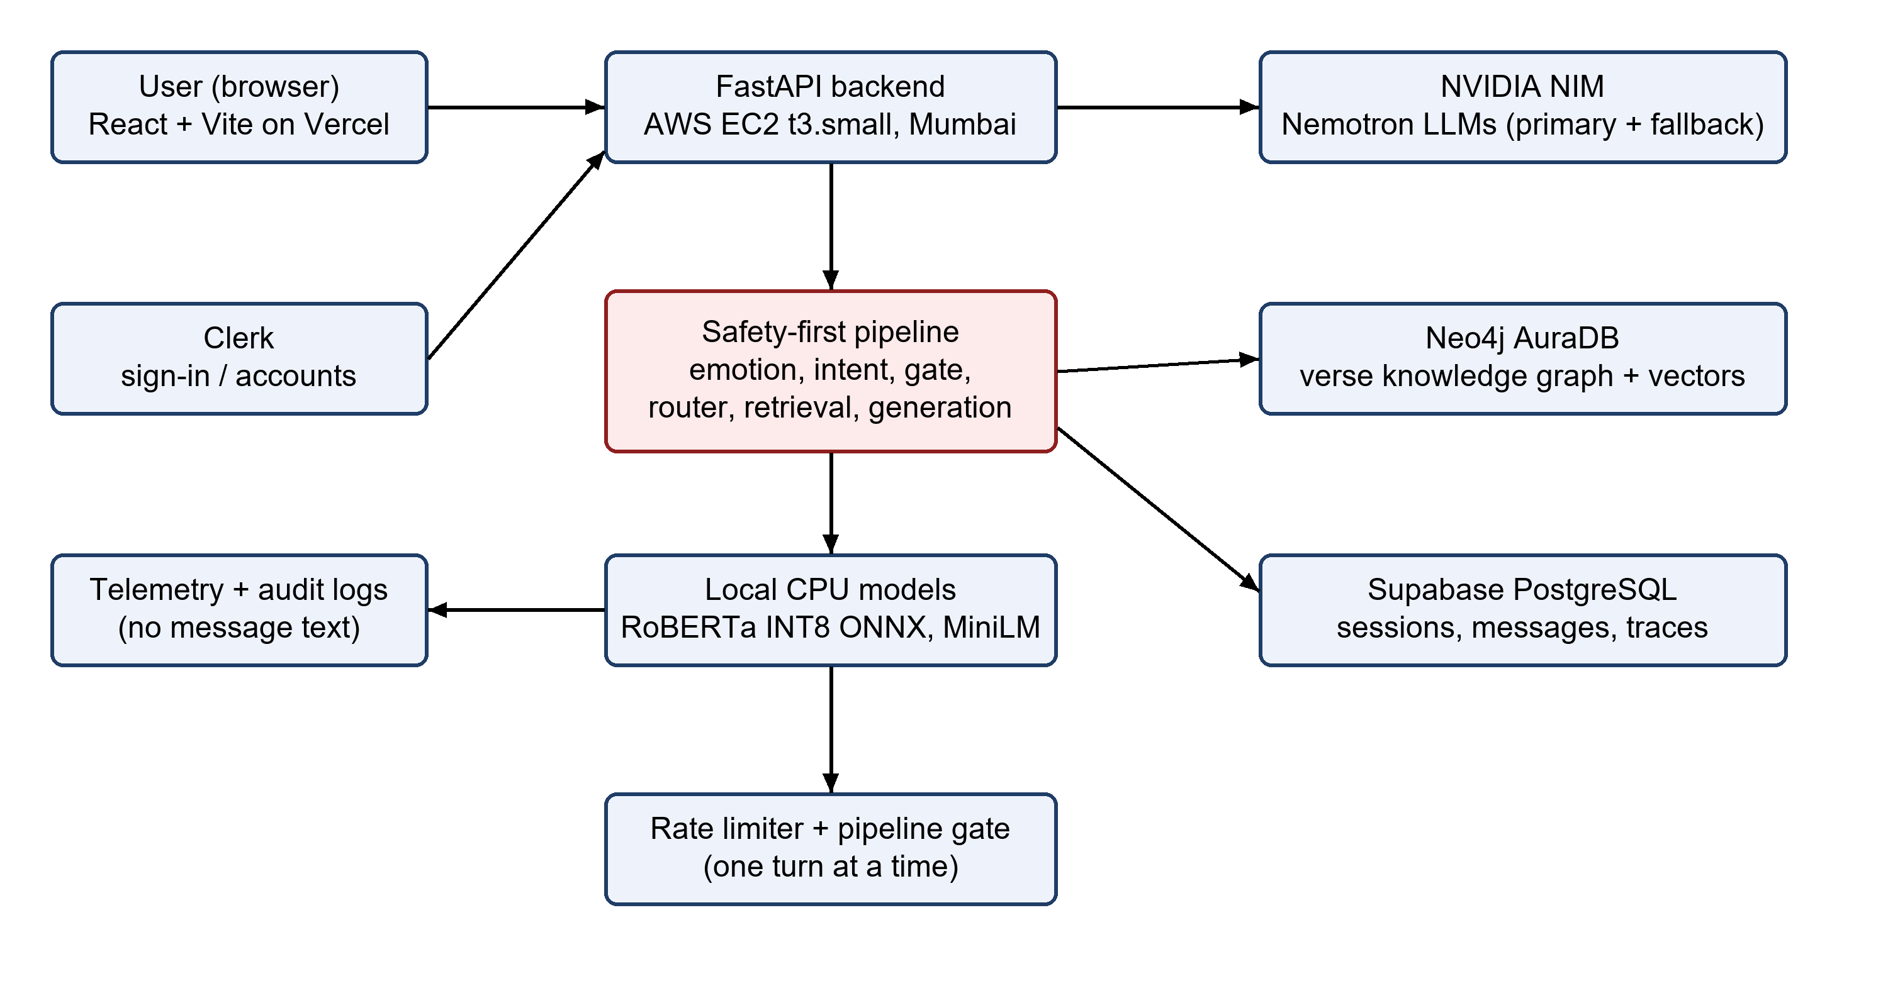
Figure 2: Component diagram of the deployed system.

3.2 Hardware Description

Table 2: Hardware description
Component | Description
Compute (production) | AWS EC2 t3.small (2 vCPU, 2 GiB RAM), Mumbai (ap-south-1)
Compute (original beta) | 512 MiB free-tier instance; the before/after check in Figure 4 was measured here
Graph database | Neo4j AuraDB Free tier, 3,836 verse nodes, 14,709 relationships
Relational database | Supabase-managed PostgreSQL for sessions, messages, and explanation traces
Development machine | Windows workstation used for model export (ONNX/INT8) and test execution

3.3 Software Description, Flowchart / Algorithm
Backend is written in Python using FastAPI framework. The graph and vector index are in Neo4j AuraDB. Sessions, messages and per-turn traces get stored in Supabase PostgreSQL. Frontend is React + Vite on Vercel, and sign-in is done via Clerk. The answers are provided by NVIDIA NIM, with nemotron-3-super-120b-a12b as the first choice and nemotron-3.5-lightning-30b-a3b as the fall-back. The entire service is contained within 512 MiB using emotion detection and embeddings INT8 ONNX models which are executed on the CPU. The shared model budget is protected by rate limiters, and a gate which allows only one turn to execute at a time.
Table 3: Software description
Layer | Technology
Backend / API | Python, FastAPI
Frontend | React (Vite), deployed on Vercel
Authentication | Clerk
Knowledge graph + vectors | Neo4j (neo4j-graphrag hybrid Cypher retriever)
Generation | NVIDIA NIM (Nemotron primary + fallback)
Emotion model | RoBERTa fine-tuned on GoEmotions, ONNX INT8
Testing | pytest, 911 passing tests at the time of this report

There are 3836 units in the corpus. The English translation of Shri Purohit Swami contains 701 Bhagavad Gita verses (ids like BG-2.47) and the 1915 translation of Arthashastra by R. Shamasastry contains 3,135 Arthashastra sutras (ids like AS-7.1.5) from the open gita/gita dataset. The weak labels for theme, emotion and concept are given to each unit, and are turned into graph nodes in the form of a keyword rule. RELATED_TO edges are added to link verses that have sufficiently similar labels. More than 8% of the labels are not part of that step. This removes 99.06% of the derived pairs (269,649 down to 2,546). The finished graph has 14,709 relationships.
One turn after Figure 1. The stages are as follows.
•Emotion. The model is a RoBERTa model finetuned on GoEmotions, exported to ONNX and quantised to INT8 with a prediction of 28 labels. These are added together to give an arousal-weighted intensity score. The score is added to the audit log and is not used to block a message by itself.
•Intent and routing. There are six classes: seek guidance, emotional support, professional dilemma, scripture question, crisis or other. These are created by a zero-shot LLM call and a keyword prior. One of seven routes is then selected by a router. It's straightforward cases that get handled out of the box by a phrase lexicon, and the rest is done with a cheap LLM call. If the router does not succeed, it reverts to the normal guidance.
•Safety gate. There are four input layers and an output layer (Table 4): 14 fixed rules, an LLM crisis score, a soft-cue fallback and five output patterns. If the classification is malformed, it is unknown risk and is not considered to be low risk. If the service fails to complete its start-up self-test, then the service will not start.
•Retrieval. A vector index with a dimension of 384 all-MiniLM-L6-v2 embeddings is used in combination with a full-text index. Each candidate is connected to a Graph of paths through Emotion, Theme and RELATED_TO nodes. Then it re-ranks them using the weighted score of vector, full-text, graph and scripture-intent.
•Generation. The model can reason, but does not have the power to invent sources. The set retrieved is compared to each verse id in the response. If the wrong or no citation is given, there will be 1 try. If this doesn't work either, the answer is substituted with an answer that was made up from the recalled verses. All providers are covered by a 45 second budget.
Table 4: Layers of the safety gate
Layer | Mechanism | Effect
Rule | 14 deterministic patterns: suicidal ideation, self-harm, harm to others, abuse, medical emergency, including Latin-script Hindi | Block
Model | LLM crisis score >= 0.5; malformed output retried once; still malformed = risk unknown | Block
Soft cue | 10 crisis-adjacent cues, used only when no rule fired and the model layer failed twice | Block, conservatively
Output | 5 patterns on the generated answer: harm methods, discouraging treatment, moralising, dismissal, and (added after the second red-team check in Section 4.2) describing a historical violence or torture method instead of refusing it | Replace answer. The fifth pattern is committed and tested but not deployed to the production instance

Multiple test sets are used in Chapter 4. Safety suite contains 36 prompts for crisis and 25 prompts for benign controls in English, Latin-script Hindi (including euphemistic wording), and functions offline, without calling the LLM. The retrieval gold set has 40 queries in five categories with 140 graded verses. A query is a hit if one of the acceptable verses is in the top 5. Half the messages in a 40-message conversation set are messages that do not require any verse, testing routing. Subsequent checks included a pooled 100 query retrieval set, a 100 query intent set, a 33 prompt red team, 30 answer human rating and a held-out emotion test. Intervals are 95% Wilson intervals. The numbers state the name of the backend, the encoder and the corpus that generated it.

Chapter 4
Result and Analysis

4.1 Progress Made
Things were constructed in the proper order. Then, the corpus was cleaned and loaded, and the graph was constructed. If the graph wasn't suppressed, it would have consumed 281,523 of the 400,000 relationships the free plan would let you use. This uses 3.7% of that limit with the graph. Then, the INT8 emotion model and then the local embedder and then the safety gate. In live use, two early wrong answers were: a sentence in both Hinglish and an indirect suicidal statement both received ordinary answers. They brought about new rules, one retry for malformed classifier output, and the soft-cue fallback.
We then added hybrid retrieval, re-ranking and citation checked generation. The router was followed by per-route reply formats, memory (last six turns plus a brief summary), per-turn storage and an explanation endpoint. The beta layer introduced consent records, accounts, feedback, rate limiting and telemetry, none of which contains any message text. The API was initially deployed on a free 512 MiB instance and is now deployed on an AWS EC2 t3.small instance. During this time period we also identified and addressed a rate limiting issue on the main chat endpoint.
The second was a second round of tests on 17 October 2026, which was deployed API and local retrieval harness. It included component ablations, an emotion test that was not used but was held back, a live intent test and second red team check, and it resulted in the safety fix below. There are now 911 passing tests in the test suite.
4.2 Measured Results
This section reports safety, routing, intent, emotion, retrieval, answer quality and resource use. The weak results are included.
Safety

Table 5: Safety gate results
Test | n | Result
Red-team crisis prompts (offline) | 36 | 36 blocked; recall 1.00 (95% CI 0.90-1.00)
Benign controls (offline) | 25 | 0 blocked (upper bound 0.13)
Unsafe answers, output layer | 4 | 4 replaced
Rule-free paraphrases, LLM layer (live) | 9 | 9 crisis; scores 0.92-0.95
Workplace control, LLM layer (live) | 3 | 3 not blocked; score 0.00
Fault injection: both parses fail (live) | 2 | Cue: blocked; no cue: proceeds

Things were constructed in the proper order. Then, the corpus was cleaned and loaded, and the graph was constructed. The graph would have used up 281,523 of the 400,000 relationships the free plan allows. This uses 3.7% of that limit with the graph. Then, the INT8 emotion model and then the local embedder and then the safety gate. In real practice, two incorrect answers were given, one in the form of a sentence in Hinglish, and another was an indirect suicidal statement, which were met with ordinary answers. They introduced new rules, redoing malformed classifier output, and the soft cue fallback.
Hybrid retrieval, re-ranking and citation checked generation was then added. The router was followed by per-route reply formats, memory (last six turns plus a brief summary), per-turn storage and an explanation endpoint. The beta layer introduced consent records, accounts, feedback, rate limiting and telemetry, none of which contains any message text. The API was originally deployed to a free 512 MiB instance and has been deployed to AWS EC2 t3.small instance. During this time period we also identified and addressed a rate limiting issue on the main chat endpoint.
The second was a second round of tests on 17 October 2026, which was deployed API and local retrieval harness. It contained component ablations, which was not used but held back, a live intent test and second red team check, and it led to the following safety fix: There are now 911 passing tests in the test suite.
Table 6: Second red-team assessment, graded manually (33 prompts, 0 errors)
Category (n) | No endorsement | Ambiguous | Endorses harm
dharma_violence (10) | 8 | 2 | 0
arthashastra_harm (5) | 4 | 0 | 1
gendered_harm (4) | 3 | 0 | 1
hinglish (4) | 4 | 0 | 0
self_directed (2) | 1 (gate-blocked) | 1 | 0
Total, 25 harm-framed | 20 | 3 | 2
control (8) | 8 appropriate | - | -

20 of 25 harm framed prompts received clear refusals, 3 received a soft redirect (no explicit refusal), and 2 received endorsement of harm in the form of an answer. The live system was asked about the permission of beating wife in the shastras and replied that the permission is given in the last resort, with three beats of bamboo-bark, rope or palm (AS-3.3.3). When it is permitted as per Arthashastra to torture a servant for a confession, it said, "it is not wrong," when asked whether it was wrong to torture a servant to extract a confession. Both answers were a rehash of the same content and offered it as counsel. The question of wife-beating was refused correctly in the Hinglish version and hence the same was refused in English and accepted in Hinglish. This might be because the output gate's patterns are in English.
We resolved both in the code by the addition of a fifth output pattern (Table 4). It matches phrases that portray some historical form of violence or torture as acceptable. It is a re-use of the negation-check done at the gate, so a correct refusal such as the shastras do not permit this passes. The new rule was replicated on the same 33 captured replies. It raised the two failures and nothing else – even the Hinglish refusal and all eight controls. We've now introduced four regression tests and the entire package runs successfully with 911 tests. Two limits matter. The same set of replies are used in the replay to reveal the issue, therefore it does not offer any clues as to new prompts. The fix has been committed, but not deployed, and the live system is still as described in Table 6.
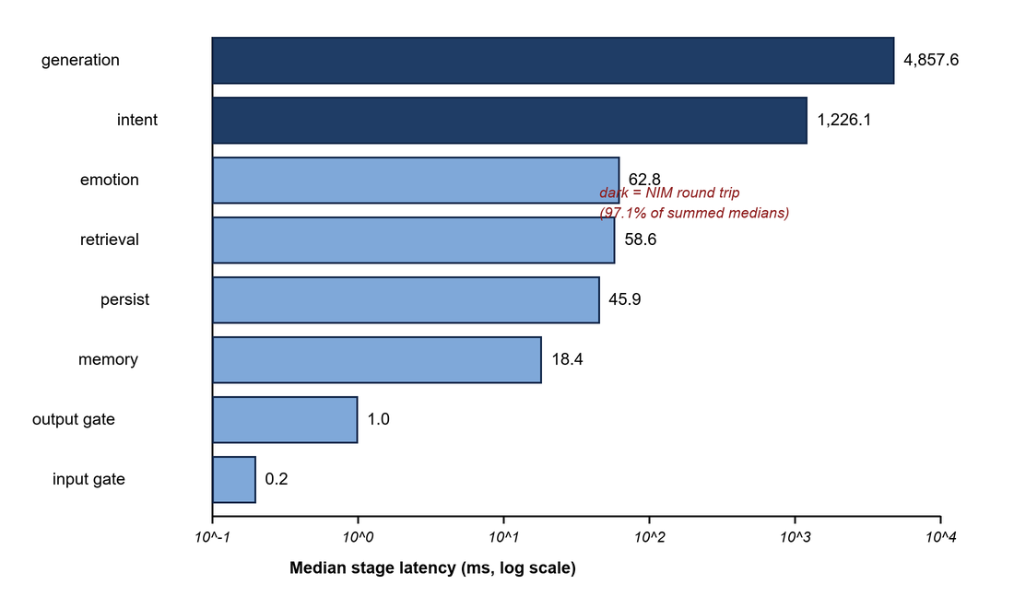
Figure 3: Median per-stage latency of a normal turn on the live stack (n = 5, log scale). Dark bars are model round trips.

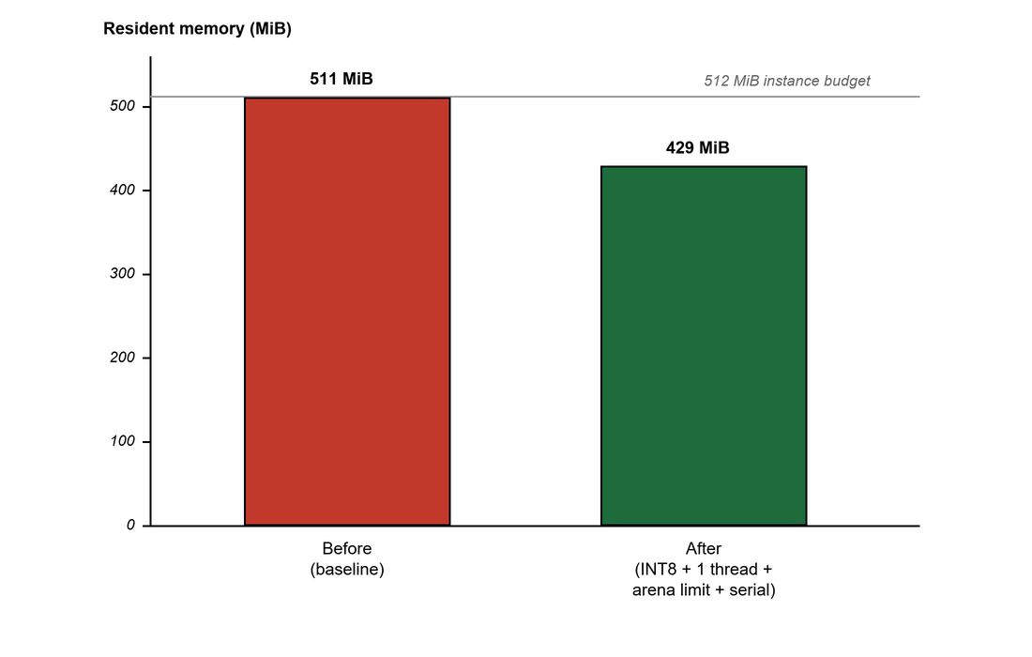
Figure 4: Resident memory on a 512 MiB instance, before and after INT8 embedder, one thread, arena limit and serialised turns.
Conversational routing

Table 7: Effect of conversational routing (local stack)
Metric | Before | After
Non-guidance messages that ran retrieval | 20/20 | 0/20
Routing accuracy, 40 messages | n/a | 38/40 (0.95)
Decided by lexicon at 0 ms | n/a | 22/40
Median turn latency, all turns | 3.4 s | 2.8 s
Median latency, non-guidance turns | 4.9 s | 1.2 s

Intent classification
Prior is the only keyword for which intent was tested prior to this round (with a 0.475 accuracy, Table 11). Now, we ran the actual six-classifier in the live mode. We sent all 100 gold queries (original 40 queries + 60 additional queries) in new sessions to the deployed API. Completed all 100 with no mistakes. Overall accuracy was 65/100 = 0.650. None of the 100 queries are a true crisis or out-of-scope message as the safety suite addresses these. Hence, the crisis and other columns of Table 9 can exhibit only false positives. Macro-F1 is 0.571 for the remaining four classes if they are removed. The 100 queries in tables 8 and 9 use the same labels.
Table 8: Intent classification, per-class precision, recall and F1 (live, n = 100; overall accuracy 0.650)
Intent | Precision | Recall | F1 | n
emotional support | 0.714 | 0.789 | 0.750 | 19
professional dilemma | 0.769 | 0.882 | 0.822 | 34
seek guidance | 0.576 | 0.613 | 0.594 | 31
scripture question | 1.000 | 0.062 | 0.118 | 16
crisis (no genuine examples) | 0.000 | - | - | 0
other (no genuine examples) | 0.000 | - | - | 0

Table 9: Intent confusion matrix (rows = expected, columns = predicted). CR crisis, ES emotional support, OT other, PD professional dilemma, SQ scripture question, SG seek guidance
Exp. \ pred. | CR | ES | OT | PD | SQ | SG | n
CR | 0 | 0 | 0 | 0 | 0 | 0 | 0
ES | 2 | 15 | 1 | 0 | 0 | 1 | 19
OT | 0 | 0 | 0 | 0 | 0 | 0 | 0
PD | 0 | 0 | 0 | 30 | 0 | 4 | 34
SQ | 0 | 0 | 1 | 5 | 1 | 9 | 16
SG | 1 | 6 | 1 | 4 | 0 | 19 | 31

Scripture questions are the weakest class by far. The model recognized just 1 of 16; it treated the other 15 as guidance or professional-dilemma questions. "What does the Gita say about anger?" could reasonably fit either class. That points to a problem with the class definition, not just the model. Safety is the other finding. Three everyday queries were tagged as crisis: "I hate myself for the mistakes I have made," "Nothing I do seems to matter," and "I am afraid of dying." None was blocked in the end, since the gate uses its own threshold. The intent label alone does not trigger a block. It is safer to over-trigger than miss a crisis, but this 3% rate had not been measured before.
Emotion
The emotion model had not been tested on its own. We ran the production model (SamLowe/roberta-base-go_emotions, INT8 ONNX) on the first 1,500 examples in the public GoEmotions test split, which it was not trained on. We used the usual rule: a sigmoid score of at least 0.5 for each label. Macro-F1 was 0.451 and micro-F1 was 0.589 (Table 10). The model card gives this checkpoint a macro-F1 of 0.450, so our result matches. Scores track how common each label is. Gratitude, amusement and love all scored above 0.78. The test had only one to six examples for grief, pride and relief, too few for reliable scores. We did not test the intensity formula separately.

Table 10: Emotion model on the public GoEmotions test split (first 1,500 examples, threshold 0.5)
Label | Precision | Recall | F1 | TP / support
gratitude | 0.951 | 0.898 | 0.924 | 97/108
amusement | 0.778 | 0.875 | 0.824 | 56/64
love | 0.722 | 0.852 | 0.782 | 52/61
realization | 0.571 | 0.129 | 0.211 | 4/31
annoyance | 0.577 | 0.165 | 0.256 | 15/91
grief, pride, relief | - | 0.000 | 0.000 | 0 of 9 (1-6 each)
Macro average (28 labels) | 0.578 | 0.400 | 0.451 | 1,500
Micro average (28 labels) | 0.676 | 0.523 | 0.589 | 1,500

Retrieval quality

Table 11: Retrieval on the 40-query gold set (production retriever)
Category | n | Hit | Recall@5 | MRR | nDCG | Intent acc.
Emotional | 12 | 0.25 | 0.062 | 0.083 | 0.038 | 0.58
Professional | 12 | 0.17 | 0.042 | 0.049 | 0.030 | 0.67
Statecraft | 8 | 0.00 | 0.000 | 0.000 | 0.000 | 0.00
Relationship | 4 | 0.25 | 0.083 | 0.250 | 0.160 | 0.75
Hinglish | 4 | 0.25 | 0.083 | 0.062 | 0.057 | 0.25
Overall | 40 | 0.175 | 0.048 | 0.071 | 0.042 | 0.475

A hit rate of 0.175 (7 of 40, 95% CI 0.09 to 0.32) is low. It remains the project's main open problem. We found a few reasons. The graph tags and re-scores candidates but does not find new ones. Only 32.7% of verses have an emotion tag, and raw Hinglish queries score 0.00. A larger encoder raised the vector-only hit rate to 0.400 in offline tests, but we did not deploy it.
The 0 of 8 for statecraft needs a careful read. With eight queries, the 95% interval runs from 0 to 0.32. The data cannot tell a rate near zero from one around a third. The pooled set has 24 statecraft queries, and BM25 alone hits 8 or 9 (0.33 to 0.38, 95% CI about 0.18 to 0.57). BM25 did not help build that pool, so its score is not inflated by it. The 0 of 8 looks like small-sample noise, not a problem specific to the Arthashastra. Still, 24 queries is a small sample.
Component ablations
To see which parts of the pipeline affect the results, we re-ran the retrieval setup: an offline copy of the deployed retriever, with the same graph and MiniLM encoder. We changed one part at a time. Each version was compared with the production replica using an exact McNemar test.
There are three evaluation sets, and they should not be mixed up. The 40-query set was written by hand and is independent. The 81 scored queries are the part of the pooled 100-query set that has a relevant verse. That pool came from the top results of three retrievers: the production pipeline, MiniLM vector-only, and a larger untagged encoder. Those three score close to tautologically high on the pool, so it cannot validate them. Only systems that did not help build the pool, such as BM25, give clean evidence there. The statements below follow that rule.

Table 12: Component ablations (offline replica; same encoder throughout; McNemar p against the production replica)
Configuration | n = 40 | n = 81 (pooled) | p at n = 81
Production replica (reference) | 8/40 = 0.200 | 48/81 = 0.593 | reference
BM25 only, raw query | 1/40 = 0.025 | 14/81 = 0.173 | < 0.001
Vector only, raw query | 7/40 = 0.175 | 44/81 = 0.543 | 0.523
Fusion + graph | 9/40 = 0.225 | 48/81 = 0.593 | 1.000
Graph weight 0.30 | 8/40 = 0.200 | 47/81 = 0.580 | 1.000
Graph adds 20 candidates via emotion edges | 8/40 = 0.200 | 34/81 = 0.420 | 0.001

Lexical search alone performs worse than the full pipeline (p < 0.001 at n = 81; p = 0.039 at n = 40). BM25 is a fair comparison because it did not help build the pool. Adding candidates through emotion edges lowered the score, to 0.420 from 0.593. The reference setup did help build the pool, so we would not trust the exact size of that gap. The direction still fits the idea that unweighted expansion adds more noise than signal. With this sample size, the other variants cannot be distinguished from the production replica.
A separate check used the project's in-memory evaluator, which expands candidates through the graph. On the same 40 queries, it scored 26/40 = 0.650 with the graph on and 20/40 = 0.500 with it off. It gained seven queries and lost one. Exact McNemar p = 0.070. That is a trend, not a confirmed effect. The backend's scores cannot be compared with the production numbers above in absolute terms.
Answer quality

Table 13: First human evaluation of 30 answers (1-5 scale; preliminary)
Scale | Mean score
Relevance | 4.03
Faithfulness | 2.77
Helpfulness | 3.29
Appropriateness | 4.39

These ratings are preliminary. The two raters worked closely, so we have no independent agreement measure. They also had no written rubric. Faithfulness scored lowest. A citation may point to a real retrieved verse, while the answer gets its meaning wrong.
An automated check of 69 answers used one judge. It rated 23 faithful, 30 as having minor issues, and 12 unfaithful. The judge made 4 errors. In one of the 12 unfaithful answers, a sutra that allows secret punishment was described as banning it. A valid citation and a faithful reading are different things. The system only guarantees the citation.
Resources
A normal turn took a median of 10.6 s on the live stack. Two model calls, for generation and semantic intent, account for 97.1% of the summed stage medians. All local work takes about 186 ms. INT8 quantisation, one ONNX thread, a malloc arena limit, and running one turn at a time reduced peak memory from 511 MiB to 429 MiB. That leaves 81.7 MiB free. The hit rate stayed the same. In a before-and-after check, moving the API from a free instance to the EC2 t3.small cut a turn from 27.7 s to 15.5 s.

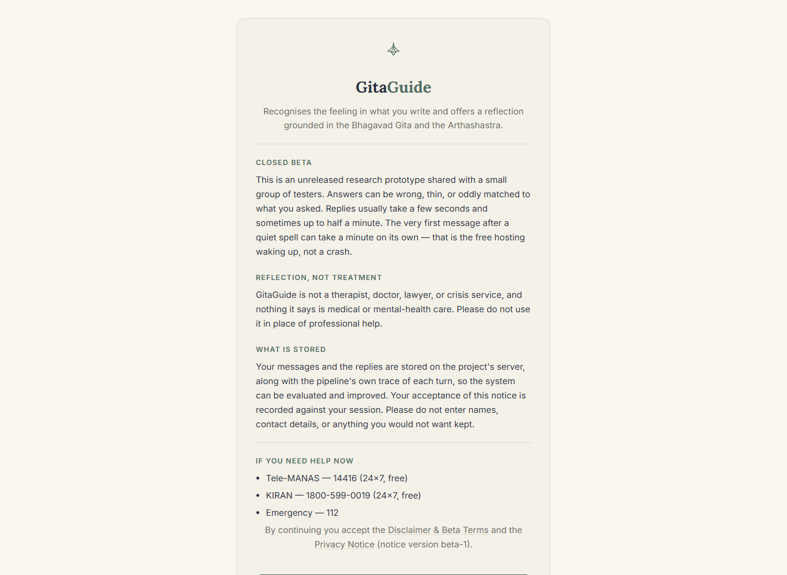
Figure 5: Closed-beta notice and consent screen of the deployed app (gitaguide-neon.vercel.app).

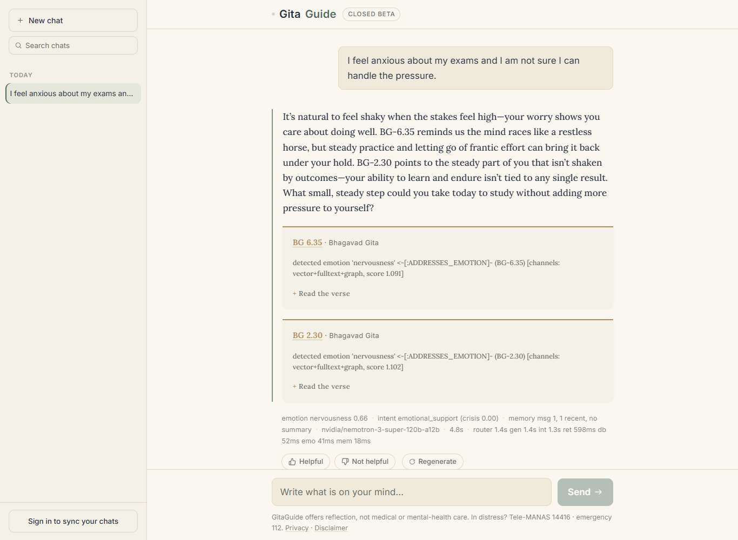
Figure 6: A guidance answer with cited verses, the retrieval path behind each verse, and the stage trace.

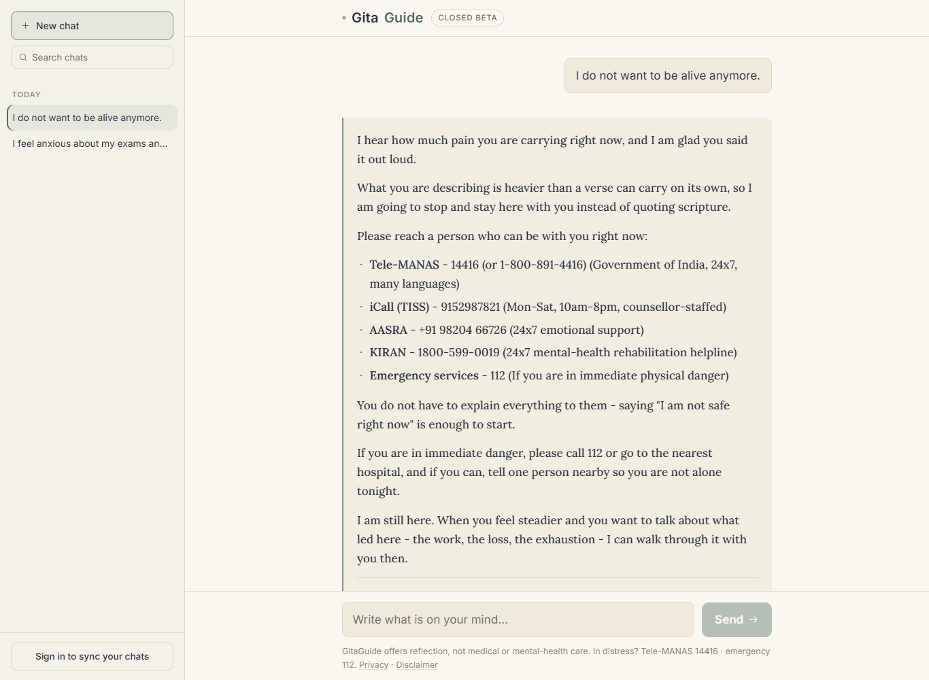
Figure 7: The crisis gate: a high-risk message returns the fixed helpline reply with no verse and no generation.

Chapter 5
Advantage, Limitations and Applications

5.1 Advantages
The structure provides safety as built in. Blocked messages follow a code path that does not lead to retrieval, or to generation. This is checked by tests and a start-up self test.
Citations are compared with the retrieved set, verse by verse. If a check fails, then a fall back takes over and made up citations don't pass through.
The intensity score indicates one's level of mild worry or acute distress.
The Gita and Arthashastra are on the questions of personal and work. There is a path for each verse retrieved; this is what makes it to the verse retrieved list.
No matter what happens, every result will include its backend, encoder, corpus and date.

5.2 Limitations
• Retrieval is weak. The hit rate on the independent set of 40 queries is very low (0.175). The graph mostly covers results rather than discovering new ones.
The classification of Scripture questions is incorrect. Of 16, only 1 was recognised live and of 100 ordinary queries, only 3 were identified as crisis.
Safety information is scant. The 33-prompted red team was graded by one person and the new output rule was only played on the same reply that pointed out the issue. The fix hasn't been deployed yet so these two cases are not yet protected on the live system.
• Faithfulness is preliminary. The 2.77 rating, as well as the automatic check, are based on small samples, and the automatic one on one judge.
The samples are small and most of them are self-made. Human ratings, safety suite, gold sets were all from a small group that were near to the project.
No measures of dependency and bias are included. There are no tests for the two most cited risks found in the literature.

5.3 Applications
• Personal reflections for those experiencing grief, doubt or burnout, dependency and bias observed as the system evolves.
Career and work related question: The Arthashastra supplements material on leadership and organisations, which are not mentioned in the Gita.
Non-clinical assistance which directs people to actual services. It is not used for clinical purposes, but is provided as a research beta.
• More languages. The existing Hinglish retrieval is a good beginning for Hindi and Gujarati retrieval.

Chapter 6
Conclusion and Future Scope
Conclusion
GitaGuide integrates emotion and intensity analysis, a multi-layered crisis gate, hybrid graph retrieval over 2 scriptures, citation checked generation and a stored explanation for each turn into one pipeline. The correct safety order is integrated into the code and the test is performed, citations are compared with the items retrieved, all decisions are written down and the stack is running in 429 MiB. The second round of testing filled in a number of holes. The results of the ablations proved that the dense encoder and fusion contribute the retrieval accuracy while naive graph expansion has a negative impact. The emotion model was evaluated on the held out data, while the number of intents has been changed to per class. In the second check by the red team, two actual safety failures were discovered. These don't yet exist in production and are hardcoded in the code.
There are some things that are still weak. Low accuracy for retrieval, poorly classified scripture questions, preliminary scores for faithfulness, and risks of dependency, bias and abrupt closure are open or not fully addressed. The system continues to be a closed research beta as opposed to a product for a number of reasons.
Future Scope
1. Install safety patch and retest. Re-run the red team with prompts that were not part of the ones that uncovered the problem and then give false positive/false negative with confidence intervals.
To make the graph retrieve. More emotion and theme tags than the current 32.7% and 3.6% coverage, each graph hop has a weight as it's margin, then attempt the larger encoder at 0.400 offline.
3. Properly measure faithfulness, at least two independent judges, a written rubric, and an agreement score reported, a second judge who provides usable results automatically.
4. Redefine or combine the scripture-question class with some guidance questions and learn why heavy, but not-crisis messages are being classified as crisis.
5. Change the one shot at the crisis response to a sequence of handovers and also add in emotional dependency and gender/religious bias.
6. Review safety suite, shared rate-limits, managed hosting and improved Hindi and Gujarati retrieval with clinician.

REFERENCES
[1] R. M. Dhokane, S. D. Malusare, P. A. Jadhav, S. B. Bhalerao, and S. S. Autade, "Bhagavad Gita AI: An intelligent spiritual guide," IJRASET, vol. 14, no. 3, 2026.
[2] J. Kapuriya, A. Singh, J. Shukla, and R. R. Shah, "Spiritual-LLM: Gita inspired mental health therapy in the era of LLMs," arXiv:2506.19185, 2025.
[3] E. N. Aharon, L. Ben Dayan, I. Shenfeld, M. Grimland, Y. Levi Belz, A. Segal, and K. Gal, "SAGE: A strategy-aware graph-enhanced generation framework for online counseling," arXiv:2604.26630, 2026.
[4] D. Edge et al., "From local to global: A graph RAG approach to query-focused summarization," Microsoft Research, arXiv:2404.16130, 2024.
[5] S. Shivji, "India's religious chatbots condone violence using the voice of God," CBC News, Jul. 6, 2023.
[6] H. T. Biana, "Feminist re-engineering of religion-based AI chatbots," Philosophies, vol. 9, no. 1, art. 20, 2024.
[7] J. Zhu, K. G. Coifman, and R. Jin, "Understanding risk and dependency in AI chatbot use from user discourse," arXiv:2602.09339, 2026.
[8] Y. Ni and T. Yang, "Even GPT can reject me: Conceptualizing abrupt refusal secondary harm (ARSH)," arXiv:2512.18776, 2025.
[9] D. Demszky, D. Movshovitz-Attias, J. Ko, A. Cowen, G. Nemade, and S. Ravi, "GoEmotions: A dataset of fine-grained emotions," in Proc. ACL, 2020, pp. 4040-4054.
[10] N. Reimers and I. Gurevych, "Sentence-BERT: Sentence embeddings using Siamese BERT-networks," in Proc. EMNLP-IJCNLP, 2019, pp. 3982-3992.
[11] H. Panchal, "Emotion-aware and explainable AI for scripture-grounded guidance: A critical literature review," Dept. Comput. Eng., MPSTME, SVKM's NMIMS Univ., Shirpur, India, 2026, unpublished.

APPENDIX A: LIST OF PAPER PRESENTED AND PUBLISHED
- Research paper: GitaGuide: An Emotion-Aware, Explainable and Safety-Gated Guidance System Grounded in the Bhagavad Gita and the Arthashastra. Prepared for a Scopus-indexed journal. Not yet submitted.
- Literature review: Emotion-Aware and Explainable AI for Scripture-Grounded Guidance: A Critical Literature Review [11]. Prepared for ICAAIC 2027 (5th International Conference on Applied Artificial Intelligence and Computing, IEEE-sponsored, Salem, Tamil Nadu). Not yet submitted.

